Task1:

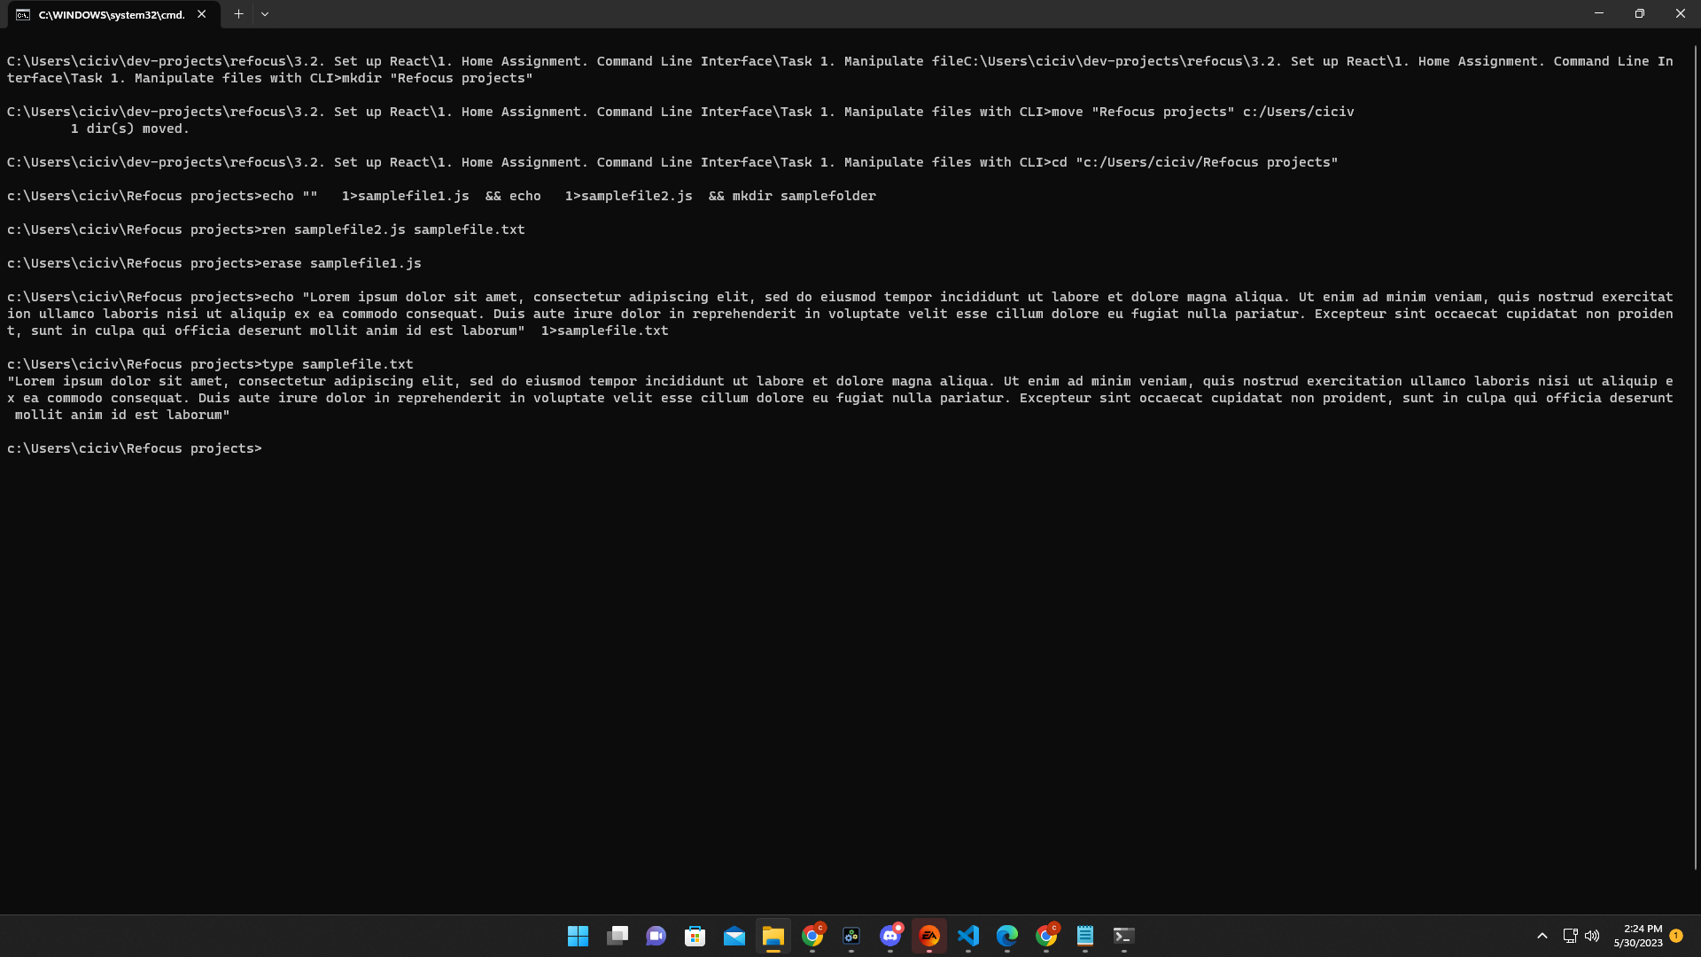

Task 2:

